BI Tools and Apache Kylin

Date: Sep 2016
Updated: Dec 2016
Author: Ramón Portolés, Alberto Linkedin
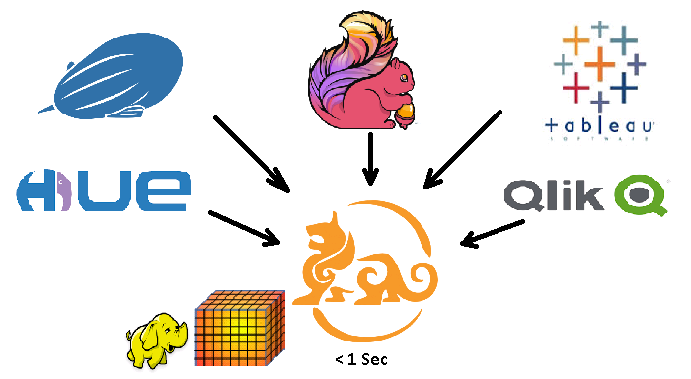

Intro: Kylin Project
Apache Kylin is a powerful software which enables Extrem OLAP cubes on Hadoop system, with lineal scalability and sub-second response time over TB of data
Mainly developed by eBay and Kyligence.io teams

Unfortunately is little known, perhaps some causes can be:
- Few documentation: some nice features are undocumented, only developers know how to use them
- It is developed / used by big companies with many technical and human resources
- The access to data, is using a integrate UI Kylin or ODBC / API Rest, too complex for most of users or PoCs

Intro: Integration Study with BI
During two months (July & August 2016) I tried to connect kylin with most popular BI Tools, sometimes has been successful others .… it hasn’t
Officially the Kylin ODBC Driver only has been tested with Tableau Software
We evaluate two aspect:
- Connectivity to import data
- Integration of this data with different features of this BI Tool
For our test use : Use Kylin v1.5.2 (on docker) Kylin ODBC v1.5

Resume Table
Soft | Data Import | Data Integration | Detailed Manual | Version | License
Tableau Desktop |  |  | GitHub | v9.3.3 | Free
Apache HUE |  |  | GitHub | v3.10 | GPL
Qlik Desktop |  |  | GitHub | v3.0.2.0 | Free
Apache Zeppelin |  |  | External | V0.7 | GPL
Apache Flink |  |  | GitHub | V1.2 | GPL
SQuirrieL |  |  | GitHub | 3.7.1 | GPL
Kylin Caravel |  |  | Internal* | v0.91 | GPL
Sisense |  |  | Internal* | v6.4.1 | Demo
Microsoft PowerBI |  |  | N.A | v2.38.4491 | Free
Dundas BI |  |  | Intenal* | V3.0.2.100 | Demo
Microsoft SSRS: Report Builder |  |  | Internal* | V2012 SP3 | Demo
Microsoft SSRS: SSDT |  |  | Internal* | V2012 SP3 | Demo
Internal*: Despite efforts, any remarkable result , But if you are interested I can share them with you
License:
- GPL: Full features are free , code free
- Free: With no code, but for free.
- Demo: Limited usage to certain period of time.

Tableau
View full Report
Resume:
- Some warning importing metadata but no issues when it is done.
- The data integration is complete

Apache Hue
View full Report
Resume:
- Some issues and code changes must be made before compiling (see steps in manual)
- View / Import meta-data is not available, more changes in code are needed(exits GIRA)
- Only 1000 rows can be Imported (exits GIRA)
- Isn’t compatible with Dashboards (In Road-map for v4)
- It’s a dynamic and important open source project, in next versions > 3.11 some bugs will be fixed

Qlik Desktop
View full Report
Resume:
- Because there isn’t an official connector, you must write “load script”, it’s easy and works fine (see instructions)
- This type of data have some limits:
  - You can’t see the data preview
  - The associations (between tables are automatically made), can’t be change. This means if they aren’t correct, your results will be worng
- Technical Support

SQuirreL (Unversal SQL Client)
View full Report
The configuration is not very intuitive, but works very well and get us a lot of information about tables metadata
Indicated for PoC or Kylin UI alternative
Not use ODBC driver uses JDBC directly then:
- Good for performance and avoid ODBC problems
- The version of Kylin and JDBC must be the same (upgrade Kylin implies upgrade your Java lib)

Apache Zeppelin
Apache Kylin Interpreter for Apache Zeppelin
Apache Zeppelin is Web notebook very useful for generate dynamic reports which integrate data from differents datasources (Hive, Spark, Kylin, Flink, PostgreSQL, HBase, .. )
You can found exaples in ZeppelinHub and Hortonworks Zeppelin Gallery

Apache Flink
ReadKylinFromFlink
Apache Flink is a Framework to process data in batch or streaming mode
Now we can read Kylin’s data from Apache Flink, Flink 1.2 or higger is recomended

Kylin Caravel
Caravel is a UI for data exploration, developed by Airbnb, that uses Druid, as database
Rocky Qi (thanks, for the suggestions) creates a fork Kylin – Caravel, to support Kylin as database

After 2 weeks of running tests, (there is a bug in the internal metadata database) and previous branch didn’t work on Ubuntu (there is some problems with this SO) and Centos… I desisted (sorry)
I will retry in the future / next version. Its a good candidate for docker (and makes life easier for others) (I like docker !!!)

Sisense
The answer of technical support of Sisense was that is compatible with Kylin
But, after contact with technical support, and some emails: it didn’t work and there was no manual that could explain how to configure it to make it work.
You can see this video

Microsoft PowerBI Desktop
I tried to import data using the automatic mode and writing select queries. In the best case, I could see the preview of data before an import. But the import never worked.
In logs, I saw some data conversion errors / overflows. You can see this video
The problem are some issues of ODBC connector :
- KYLIN-2121 v1.6.0 Bug "Value was either too large or too small for an Int32"
- Kylin 2235 vx.x Bug "array dimensions exceed supported ranges"

Dundas BI
(Thanks to Ariel Pohoryles, of Dundas team)
Dundas BI, Was one of the first to do graphs with high visual quality
Microsoft purchased a license to use Dundas Chart on SQL Rerporting services 2008 and above
There is a demo for 45 days
Nowadays, there is a bug reading metadata (Kylin 2274), Afer review problem with Dudas Team sound like a problem with ODBC (explanation)

Microsoft SSRS: Report Builder
Microsoft Report builder , is a end user tool for create your personal Reports (from Web UI) on SSRS server or SharePoint
Its free with Microsoft SQL Server license
You can define Kylin as DataSource, but when use it to create DataSet fail: “Data Source name not found and no default driver speficied”

Microsoft SSRS: Visual Studio Data Tools (SSDT)
Is an extension to generate professional reports of SSRS using Visual Studio
Its free with Microsoft SQL Server license
The error is similar to that Report Builder “Data Source name not found and no default driver speficied”
It seems that only work with certains providers proposed by default by Microsoft

Others
Other tools that nowadays, can’t work with Apache Kylin (need changes in code, doesn’t support SQL, doesn’t support ODBC sources, ... )

Kibi /Kibana
From: Giovanni Tummarello (thanks, for the info)
“Kibi dashboard DO NOT support SQL or JDBC a Kibi datasource is only used for special filters or certain other operations, check the documentation. We will likely support it in the future though.
saying this so that you dont waste your time.. you will not be able to see anything now with Kibi if you dont load things in ES also”

Ploty
From: Chris Parmer (thanks, for the info)
“Thanks for reaching out! We haven't added this yet. Do you use Apache Kylin at your work? We are going to be adding spark and redshift next before we get to something like Kylin.”

DataIku
(Thanks to Hugo Schmitt)
It’s a Visualization and Machine Learning tool. Imagine, if you have sales cube by dates, predict the sales using data of previous years ;)
Extensible using Plugins
DataIku, don’t support standard ODBC connector, the workaround is test with unofifcial JDBC sopport

ToDo:
Test and doc the integration of Kylin with Saiku

For any suggestions, feel free to contact me
Thanks, Alberto

